AT1 Programming Challenge:

Kings Calculator

Introduction

Provide an overview of the project, its objectives, and its context.
The task requirements stipulate for part 1 to design and develop a calculator that can perform addition, subtraction, multiplication and division. In part 2, the task is to implement a novel logging system that records the time stamp in Roman numerals and saves the number of calculations performed as morse code. Finally, a tool should be designed to plot a triangle based on an input of two angles and save it to the file. The whole assignment should be written with clean code and lots of modularity so that the next stages can be easily implemented with minimal refactoring.

Explain the purpose and scope of the documentation.
The purpose of this documentation is to provide a real-life example of how to write pseudocode so that we are better prepared for the HSC exam. However, its primary goal is to enhance upgradability and reliability. This document is only valid for the previously stipulated task goals.

Outline the structure and organization of the documentation.
This document is structured in a format where each of the stages starting at P1, contains peusdocode, flowchart and python code. P2, contains peusdocode, flowchart and python code. P3 contains a flowchart, pseudocode, data flow diagrams and a structure chart.

Part 1
Explain the challenges, issues
The main challenges where caused by the need to make the code modular so that the next stages could be built in it with minimal refactoring. The solution is to be careful and have a full understanding of how the part 1 code will be added on by the next stages.

Flowchart:
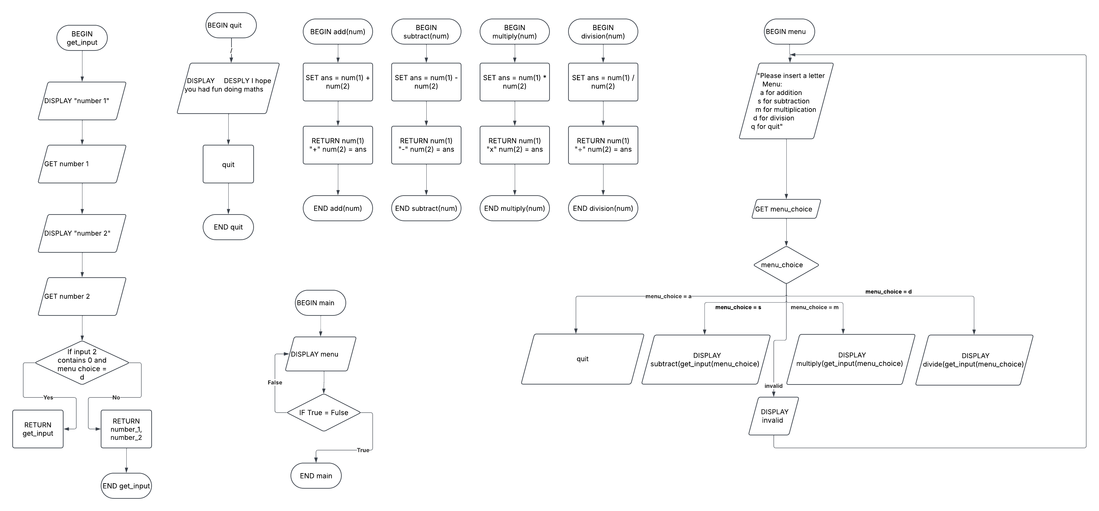

Pseudocode:

BEGIN get_input(menu_choice)
DISPLAY "number 1"
GET number_1
DISPLAY "number 2"
GET number_2

IF menu_choice = d and num(2)=0
DISPLAY you have a zero divisor
RETURN get_input()
ENDIF

RETURN number_1, number_2

END get_input()

BEGIN add(num)
SET ans = num(1) + num(2)
RETURN num(1)+ " + " +num(2) = ans
END add(num)

BEGIN subtract(num)
SET ans = num(1) - num(2)
RETURN num(1)+ " - " +num(2) = ans
END subtract(num)

BEGIN multiply(num)
SET multiply_ans = num(1) * num(2)
RETURN num(1)+ " x " +num(2) = ans
END multiply(num)

BEGIN division(num)
SET ans = num(1) / num(2)
RETURN num(1)+” ÷ “+num(2) = ans
END division

BEGIN menu
DISPLAY "Please insert a letter
Menu:
a for addition
s for subtraction
m for multiplication
d for division
q for quit"

GET menu_choice

CASEWHERE:
a: RETURN add(get_num(menu_choice))
s: RETURN subtract(get_num(menu_choice))
d: RETURN division(get_num(menu_choice))
m: RETURN multiply(get_num(menu_choice))
q: quit
_:

DISPLAY Invalid menu choice
RETURN menu
END menu

BEGIN quit
DISPLAY I hope you had fun doing maths
exit
END quit

BEGIN main
WHILE True
DISPLAY menu
ENDWHILE
END main

Python code:

# King's Calculator

def menu():
global menu_choice
print("""Please insert a letter
Menu:
a for addition
m for multiplication
s for subtraction
d for division
q for quit""")
menu_choice = input(">")

# check the menu is choice valid then call the relevent oporation
match menu_choice:
case "a" : return addition(get_and_clean_input(menu_choice)) # adds the user input
case "s" : return subtraction(get_and_clean_input(menu_choice)) # subtracs the user input
case "m" : return multiplication(get_and_clean_input(menu_choice)) # multipled the user input
case "d" : return division(get_and_clean_input(menu_choice)) # divied the user input
case "q" : quit()
case _ : print("Something whent wrong"); menu() # recursively calls menu

def get_and_clean_input(menu_choice):
num1 = input("Input the first number: ")
num2 = input("Input the second number: ")

# This converts a string to a number. If it can be converted to an integer,
# it will be converted to a float. If it cannot be converted to float.
# Then a You have made a typo make shure you input a valid number will be printed then
# function will be recursively called.
try:
try:
num1,num2 = int(num1),int(num2)
except:
num1,num2 = float(num1),float(num2)
except:
print("You have made a typo make sure you input a valid number")
print("")
return get_and_clean_input(menu_choice)

try:
if menu_choice == "d":
_ = num1/num2
except ZeroDivisionError:
print("you have a Zero Divisor")
return get_and_clean_input("d")
return num1, num2

# Since the get_and_clean_input outputs a tuple than the first and second elemtes are added
def addition(num):
return f"{num[0]} + {num[1]} = {num[0]+num[1]}"+ "\n"
# return num[0]+num[1]

# Since the get_and_clean_input outputs a tuple than the first and second elemtes are subtraced
def subtraction(num):
return f"{num[0]} - {num[1]} = {num[0]-num[1]}"+ "\n"
# return num[0]-num[1]

# Since the get_and_clean_input outputs a tuple than the first and second elemtes are multipled
def multiplication(num):
return f"{num[0]} x {num[1]} = {num[0]*num[1]}"+ "\n"
# return num[0]*num[1]

# Since the get_and_clean_input outputs a tuple than the first and second elemtes are divied
def division(num):
return f"{num[0]} ÷ {num[1]} = {num[0]/num[1]}"+ "\n"
# return num[0]/num[1]

def quit():
print("I hope you had fun doing maths ;)")
exit()

# to make the global var calcs
print("press ctrl+c to quit")

while True:
# call to init the globe var in loop in case use in multiple days
try:
print(menu())
except KeyboardInterrupt:
print("I hope you had fun doing maths :)")
break

Part 2
Explain the challenges, issues
The main challengers faced were situated around having to change the first line on calcs.txt file I had bugs in that it wouldn't write of it would overwrite the whole file. But the solution was to isolate and rewrite the specific part through a prosses of refactoring. Then I changed it to only run on the quit function this made it so much easier.

Flowchart:
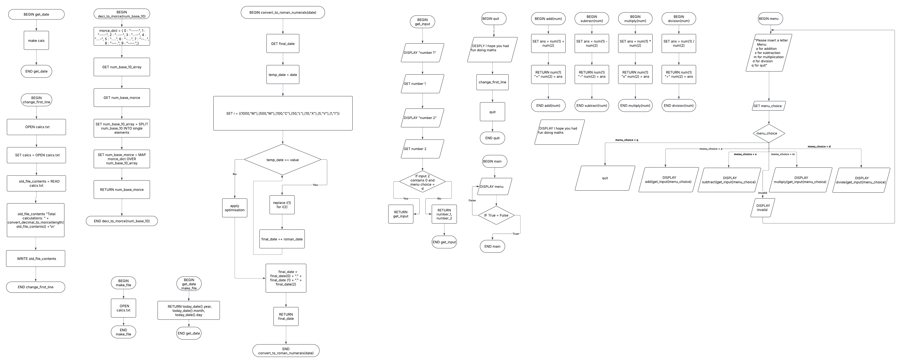

Pseudocode:

BEGIN get_input(menu_choice)
DISPLAY "number 1"
GET number_1
DISPLAY "number 2"
GET number_2

IF menu_choice = d and num(2)=0
DISPLAY you have a zero divisor
RETURN get_input()
ENDIF

RETURN number_1, number_2

END get_input()

BEGIN add(num)
SET ans = num(1) + num(2)
RETURN num(1)+ " + " +num(2) = ans
END add(num)

BEGIN subtract(num)
SET ans = num(1) - num(2)
RETURN num(1)+ " - " +num(2) = ans
END subtract(num)

BEGIN multiply(num)
SET multiply_ans = num(1) * num(2)
RETURN num(1)+ " x " +num(2) = ans
END multiply(num)

BEGIN division(num)
SET ans = num(1) / num(2)
RETURN num(1)+” ÷ “+num(2) = ans
END division

BEGIN menu
DISPLAY "Please insert a letter
Menu:
a for addition
s for subtraction
m for multiplication
d for division
q for quit"

GET menu_choice

CASEWHERE:
a: RETURN add(get_num(menu_choice))
s: RETURN subtract(get_num(menu_choice))
d: RETURN division(get_num(menu_choice))
m: RETURN multiply(get_num(menu_choice))
q: quit
_:

DISPLAY Invalid menu choice
RETURN menu
END menu

BEGIN quit
DISPLAY I hope you had fun doing maths
change_first_line
close(file)
exit
END quit

BEGIN make_file
OPEN calcs.txt
END make_file

BEGIN get_date
RETURN today_date().year, today_date().month, today_date().day
END get_date

BEGIN convert_to_roman_numerals(date)
GET final_date
FOR date = date(1) to date(-1) STEP 1
temp_date = date
roman_date = ""

SET i = ((1000,"M"),(500,"M"),(100,"C"),(50,"L"),(10,"X"),(5,"V"),(1,"I")):

FOR var = 1 to 7 STEP 1:
WHILE temp_date - i(var(0)) >= 0:
roman_date += i(var(1))
temp_date -= i(var(0))
ENDWHILE

# do the optimization like 4 = iv
roman_date = replace(roman_date,"DCCCC", "CM")
roman_date = replace(roman_date,"CCCC", "CD")
roman_date = replace(roman_date,"LXXXX", "XC")
roman_date = replace(roman_date,"XXXX", "XL")
roman_date = replace(roman_date,"VIIII", "IX")
roman_date = replace(roman_date,"IIII", "IV")
REPEAT

append(final_date,roman_date)
final_date = final_date(0) + "." + final_date (1) + "." + final_date(2)
RETURN final_date
END convert_to_roman_numerals(date)

BEGIN deci_to_morce(num_base_10)

morce_dict = { 0 : "----- ", 1 : ".---- ", 2 : "..--- ", 3 : "...-- ", 4 : "....- ", 5 : "..... ", 6 : "-.... ", 7 : "--... ", 8 : "---.. ", 9 : "----. ",}

GET num_base_10_array
GET num_base_morce

SET num_base_10_array = SPLIT num_base_10 INTO single elements

SET num_base_morce = MAP morce_dict OVER num_base_10_array

RETURN num_base_morce

END deci_to_morce(num_base_10)

BEGIN change_first_line
OPEN calcs.txt
SET calcs = OPEN calcs.txt
old_file_contents = READ calcs.txt
old_file_contence "Total calculations: " + convert_decimal_to_morce(length( old_file_contents)) +'\n'
WRITE old_file_contence
END change_first_line

BEGIN main
make_file
WHILE True
DISPLAY menu
ENDWHILE
change_first_line
END main

Python code:

# King's Calculator
import os
import datetime
import shutil

# makes a valid file
def make_file():
global file_name
global folder_name

try:
os.mkdir(folder_name:="calculations")
except FileExistsError:
shutil.rmtree(folder_name)
os.mkdir(folder_name:="calculations")

with open(file_name := "calculations/calcs.txt",'w') as calcs:
calcs.close()

def get_date():
return [datetime.date.today().day,datetime.date.today().month,datetime.date.today().year]

def convert_to_roman_numerals(date):
global final_date

final_date = []

# i know bad naming sorry
for date in date:
# this will convet integers to roman numrels but it will not do the optimisaton that like 4 = iv
temp_date = date
roman_date = ""

for i in [[1000,"M"],[500,"M"],[100,"C"],[50,"L"],[10,"X"],[5,"V"],[1,"I"]]:
while temp_date - i[0] >= 0:
roman_date += i[1]
temp_date -= i[0]

# do the optimisaton like 4 = iv
roman_date = roman_date.replace("DCCCC", "CM")
roman_date = roman_date.replace("CCCC", "CD")
roman_date = roman_date.replace("LXXXX", "XC")
roman_date = roman_date.replace("XXXX", "XL")
roman_date = roman_date.replace("VIIII", "IX")
roman_date = roman_date.replace("IIII", "IV")

final_date.append(roman_date)
final_date = final_date[0] + "." + final_date [1] + "." + final_date[2]
return final_date

def deci_to_morce(num_base_10):
morce_dict = {
0 : "-----",
1 : ".----",
2 : "..---",
3 : "...--",
4 : "....-",
5 : ".....",
6 : "-....",
7 : "--...",
8 : "---..",
9 : "----.",}
# split into a array that has each diget seperat
num_base_10_array = []
num_base_10 = str(num_base_10)
for i in range(len(num_base_10)):
num_base_10_array.append(int(num_base_10[i]))
del num_base_10
num_base_morce = ""

for number in num_base_10_array:
num_base_morce = f"{num_base_morce}" + " " f"{morce_dict[number]}"

return num_base_morce

def change_first_line():
with open(file_name,"r") as calcs:
old_file_contence = calcs.readlines()
calcs.close()

old_file_contence.insert(0, "Total calculations: " + deci_to_morce(str(len(old_file_contence)))+'\n')

with open(file_name,"w+") as calcs:
calcs.writelines(old_file_contence)
calcs.close()

def menu():
global menu_choice
print("""Please insert a letter
Menu:
a for addition
m for multiplication
s for subtraction
d for division
q for quit""")
menu_choice = input(">")

# check the menu is choice valid then call the relevent oporation
match menu_choice:
case "a" : return addition(get_and_clean_input(menu_choice)) # adds the user input
case "s" : return subtraction(get_and_clean_input(menu_choice)) # subtracs the user input
case "m" : return multiplication(get_and_clean_input(menu_choice)) # multipled the user input
case "d" : return division(get_and_clean_input(menu_choice)) # divied the user input
case "q" : quit()
case _ : print("Something whent wrong"); menu() # recursively calls menu

def get_and_clean_input(menu_choice):
num1 = input("Input the first number: ")
num2 = input("Input the second number: ")

# This converts a string to a number. If it can be converted to an integer,
# it will be converted to a float. If it cannot be converted to float.
# Then a You have made a typo make shure you input a valid number will be printed then
# function will be recursively called.
try:
try:
num1,num2 = int(num1),int(num2)
except:
num1,num2 = float(num1),float(num2)
except:
print("You have made a typo make sure you input a valid number")
print("")
return get_and_clean_input(menu_choice)

try:
if menu_choice == "d":
_ = num1/num2
except ZeroDivisionError:
print("you have a Zero Divisor")
return get_and_clean_input("d")
return num1, num2

# Since the get_and_clean_input outputs a tuple than the first and second elemtes are added
def addition(num):
return f"{num[0]} + {num[1]} = {num[0]+num[1]}"+ "\n"
# return num[0]+num[1]

# Since the get_and_clean_input outputs a tuple than the first and second elemtes are subtraced
def subtraction(num):
return f"{num[0]} - {num[1]} = {num[0]-num[1]}"+ "\n"
# return num[0]-num[1]

# Since the get_and_clean_input outputs a tuple than the first and second elemtes are multipled
def multiplication(num):
return f"{num[0]} x {num[1]} = {num[0]*num[1]}"+ "\n"
# return num[0]*num[1]

# Since the get_and_clean_input outputs a tuple than the first and second elemtes are divied
def division(num):
return f"{num[0]} ÷ {num[1]} = {num[0]/num[1]}"+ "\n"
# return num[0]/num[1]

def quit():
change_first_line()
calcs.close()
print("I hope you had fun doing maths ;)")
exit()

# to make the global var calcs
make_file()
print("press ctrl+c to quit")

while True:
# call to init the globe var in loop in case use in multiple days
convert_to_roman_numerals(get_date())
try:
print(text := menu())
with open(f"{file_name}","a+") as calcs:
if "None" in str(text):
continue
calcs.write(f"Timestamp {final_date}: {text}")
calcs.close()
except KeyboardInterrupt:
change_first_line()
print("I hope you had fun doing maths :)")
calcs.close()
break

Part 3
Explain the challenges, issues
The main challengers faced in part 3 where with little errors with the sign of a function as well as getting sin() and cos() mixed up. The solution for this is to put it through a llm help identify the small errors.

Flowchart:

Pseudocode:

BEGIN get_input(menu_choice)
DISPLAY "number 1"
GET number_1
DISPLAY "number 2"
GET number_2

IF menu_choice = d and num(2)=0
DISPLAY you have a zero divisor
RETURN get_input()
ENDIF

RETURN number_1, number_2

END get_input()

BEGIN add(num)
SET ans = num(1) + num(2)
RETURN num(1)+ " + " +num(2) = ans
END add(num)

BEGIN subtract(num)
SET ans = num(1) - num(2)
RETURN num(1)+ " - " +num(2) = ans
END subtract(num)

BEGIN multiply(num)
SET multiply_ans = num(1) * num(2)
RETURN num(1)+ " x " +num(2) = ans
END multiply(num)

BEGIN division(num)
SET ans = num(1) / num(2)
RETURN num(1)+” ÷ “+num(2) = ans
END division

BEGIN menu
DISPLAY "Please insert a letter
Menu:
a for addition
s for subtraction
m for multiplication
d for division
t for triangle
q for quit"

GET menu_choice

CASEWHERE:
a: RETURN add(get_num(menu_choice))
s: RETURN subtract(get_num(menu_choice))
d: RETURN division(get_num(menu_choice))
m: RETURN multiply(get_num(menu_choice))
t:RETURN triangle(get_angles())
q: quit
_:

DISPLAY Invalid menu choice
RETURN menu
END menu

BEGIN quit
DISPLAY I hope you had fun doing maths
change_first_line
close(file)
exit
END quit

BEGIN make_file
OPEN calcs.txt
END make_file

BEGIN get_date
RETURN today_date().year, today_date().month, today_date().day
END get_date

BEGIN convert_to_roman_numerals(date)
GET final_date
FOR date = date(1) to date(-1) STEP 1
temp_date = date
roman_date = ""

SET i = ((1000,"M"),(500,"M"),(100,"C"),(50,"L"),(10,"X"),(5,"V"),(1,"I")):

FOR var = 1 to 7 STEP 1:
WHILE temp_date - i(var(0)) >= 0:
roman_date += i(var(1))
temp_date -= i(var(0))
ENDWHILE

# do the optimization like 4 = iv
roman_date = replace(roman_date,"DCCCC", "CM")
roman_date = replace(roman_date,"CCCC", "CD")
roman_date = replace(roman_date,"LXXXX", "XC")
roman_date = replace(roman_date,"XXXX", "XL")
roman_date = replace(roman_date,"VIIII", "IX")
roman_date = replace(roman_date,"IIII", "IV")
REPEAT

append(final_date,roman_date)
final_date = final_date(0) + "." + final_date (1) + "." + final_date(2)
RETURN final_date
END convert_to_roman_numerals(date)

BEGIN deci_to_morce(num_base_10)

morce_dict = { 0 : "----- ", 1 : ".---- ", 2 : "..--- ", 3 : "...-- ", 4 : "....- ", 5 : "..... ", 6 : "-.... ", 7 : "--... ", 8 : "---.. ", 9 : "----. ",}

GET num_base_10_array
GET num_base_morce

SET num_base_10_array = SPLIT num_base_10 INTO single elements

SET num_base_morce = MAP morce_dict OVER num_base_10_array

RETURN num_base_morce

END deci_to_morce(num_base_10)

BEGIN change_first_line
OPEN calcs.txt
SET calcs = OPEN calcs.txt
old_file_contents = READ calcs.txt
old_file_contence "Total calculations: " + convert_decimal_to_morce(length( old_file_contents)) +'\n'
WRITE old_file_contence
END change_first_line

BEGIN triangle(angle_ABC)

angle_A = angle_ABC(0)
angle_B = angle_ABC(1)
angle_C = angle_ABC(2)

known_side_length = 1

unknown_side_length_to_use_in_trig = sin(angle_C)*known_side_length/sin(angle_A)
testing_side_length = sin(angle_B)*known_side_length/sin(angle_A)

x_unknown = unknown_side_length_to_use_in_trig * cos(angle_C)
y_unknown = unknown_side_length_to_use_in_trig * sin(angle_C)

points_x = (0,1,x_unknown)
points_y = (0,0,y_unknown)

plot((0,x_unknown), (0,y_unknown))
tri_file_name = triangle.png
OPEN tri_file_name
WRITE plot TO tri_file_name

angle_A = degrees(angle_A)
angle_B = degrees(angle_B)
angle_C = degrees(angle_C)

RETURN "angle_A: " + angle_A + " angle_B: " + angle_B + " angle_C: " + angle_C + "\n"
END triangle(angle_ABC)

BEGIN get_angles
angle_A = Angle 1
angle_B = Angle 2
angle_C = abs(180-(angle_A+angle_B))

angle_A = radians(angle_A)
angle_B = radians(angle_B)
angle_C = radians(angle_C)

RETURN (angle_A,angle_B,angle_C)
END get_angles

BEGIN main
make_file
WHILE True
DISPLAY menu
ENDWHILE
change_first_line
END main

Data Flow Diagrams:
Level 0
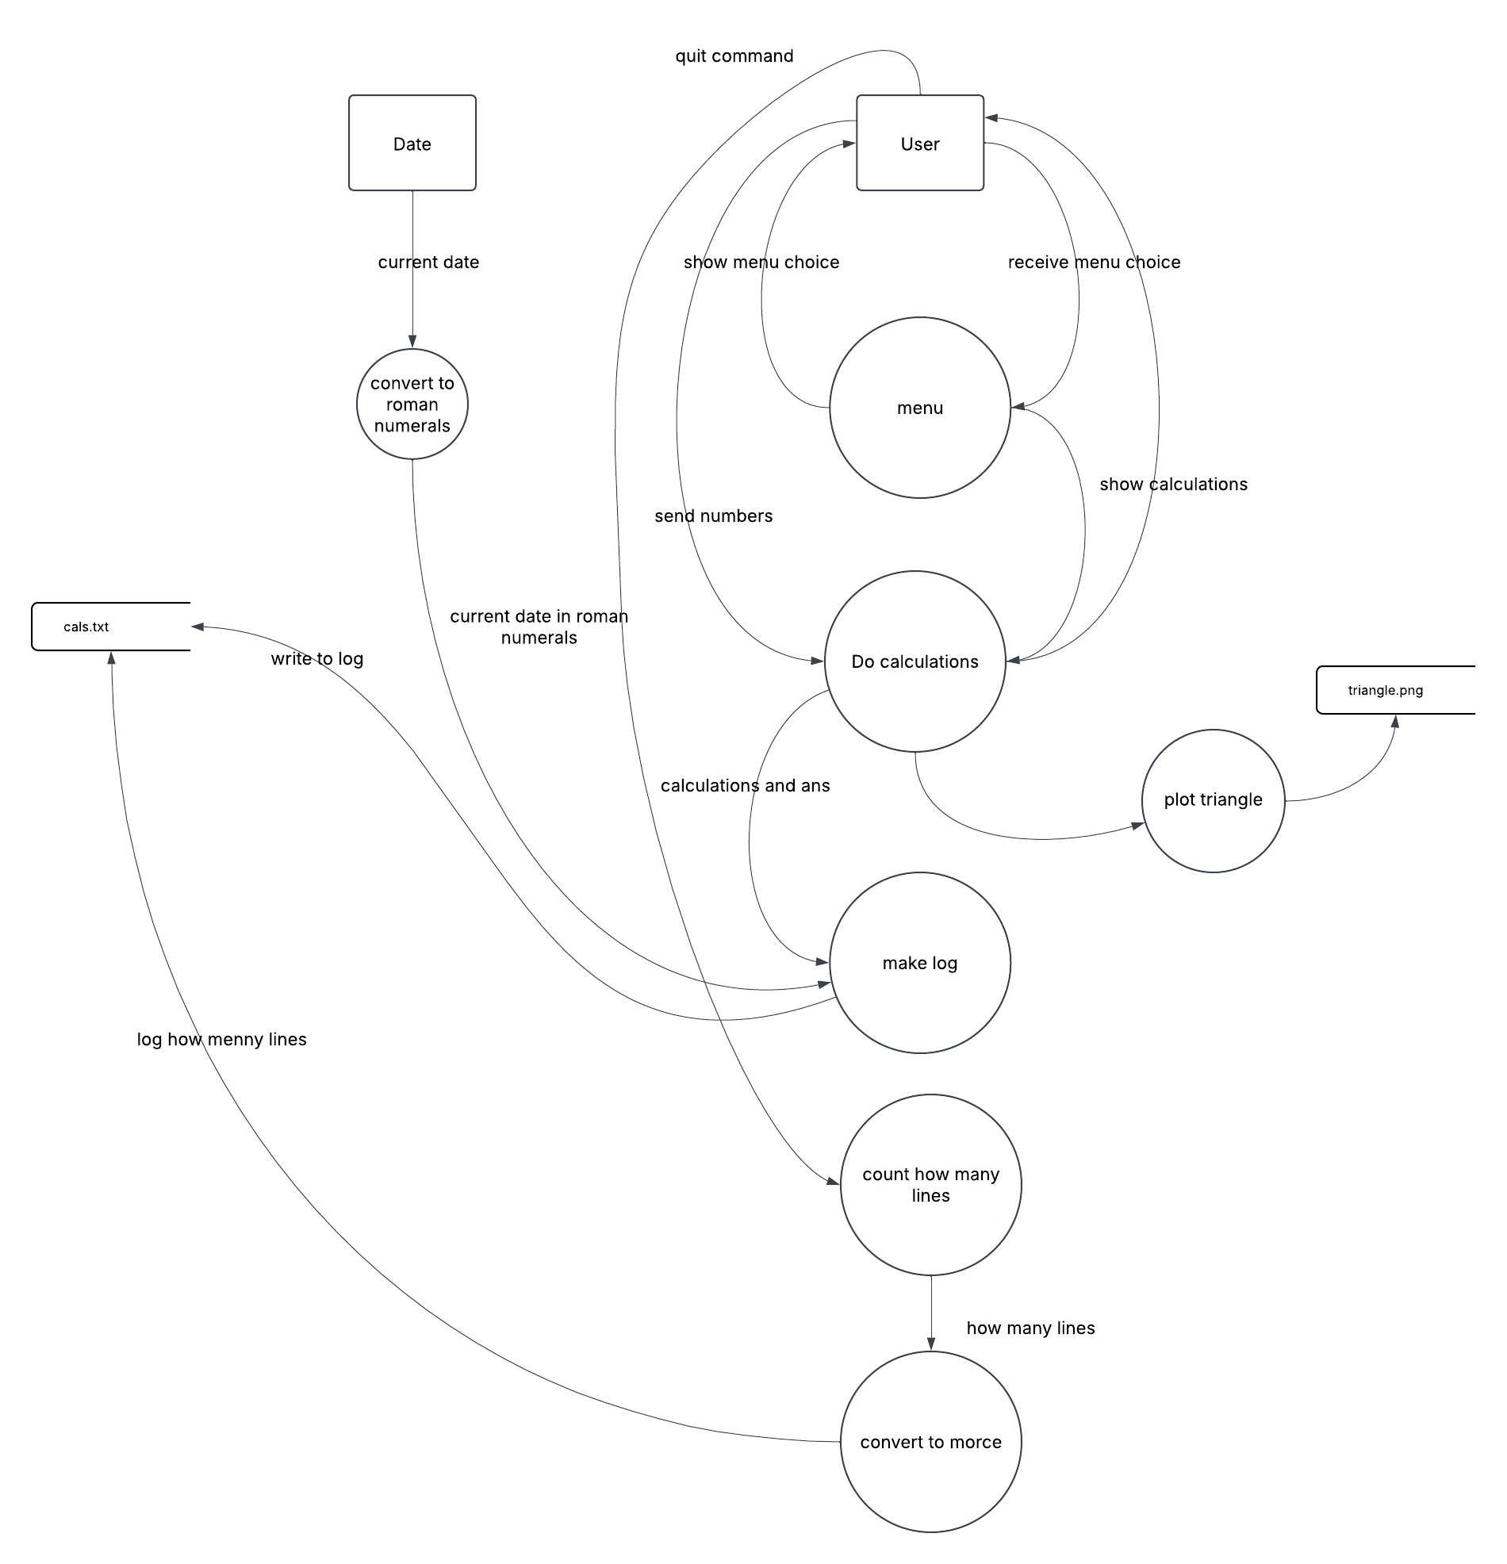
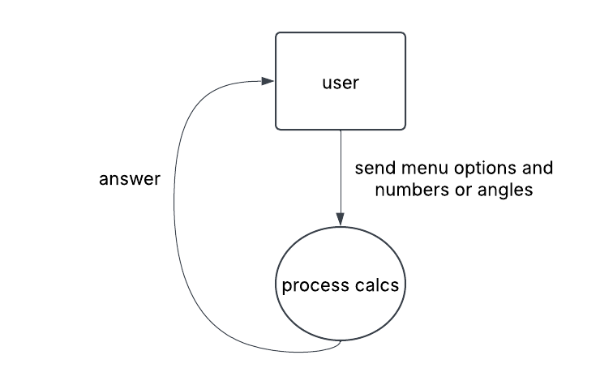
level 1

Structure chart:

Testing table:

Evaluate program compare to the requirements and improvements:

Conclusion:

Python code:

# King's Calculator
import os
import datetime
import matplotlib.pyplot as plt
from matplotlib.patches import Polygon
import numpy as np
from math import *
import shutil

# makes a valid file
def make_file():
global file_name
global folder_name

try:
os.mkdir(folder_name:="calculations")
except FileExistsError:
shutil.rmtree(folder_name)
os.mkdir(folder_name:="calculations")

with open(file_name := "calculations/calcs.txt",'w') as calcs:
calcs.close()

def get_date():
return [datetime.date.today().day,datetime.date.today().month,datetime.date.today().year]

def convert_to_roman_numerals(date):
global final_date

final_date = []

# i know bad naming sorry
for date in date:
# this will convet integers to roman numrels but it will not do the optimisaton that like 4 = iv
temp_date = date
roman_date = ""

for i in [[1000,"M"],[500,"M"],[100,"C"],[50,"L"],[10,"X"],[5,"V"],[1,"I"]]:
while temp_date - i[0] >= 0:
roman_date += i[1]
temp_date -= i[0]

# do the optimisaton like 4 = iv
roman_date = roman_date.replace("DCCCC", "CM")
roman_date = roman_date.replace("CCCC", "CD")
roman_date = roman_date.replace("LXXXX", "XC")
roman_date = roman_date.replace("XXXX", "XL")
roman_date = roman_date.replace("VIIII", "IX")
roman_date = roman_date.replace("IIII", "IV")

final_date.append(roman_date)
final_date = final_date[0] + "." + final_date [1] + "." + final_date[2]
return final_date

def deci_to_morce(num_base_10):
morce_dict = {
0 : "-----",
1 : ".----",
2 : "..---",
3 : "...--",
4 : "....-",
5 : ".....",
6 : "-....",
7 : "--...",
8 : "---..",
9 : "----.",}
# split into a array that has each diget seperat
num_base_10_array = []
num_base_10 = str(num_base_10)
for i in range(len(num_base_10)):
num_base_10_array.append(int(num_base_10[i]))
del num_base_10
num_base_morce = ""

for number in num_base_10_array:
num_base_morce = f"{num_base_morce}" + " " f"{morce_dict[number]}"

return num_base_morce

def change_first_line():
with open(file_name,"r") as calcs:
old_file_contence = calcs.readlines()
calcs.close()

old_file_contence.insert(0, "Total Calculations: " + deci_to_morce(str(len(old_file_contence)))+'\n')

with open(file_name,"w+") as calcs:
calcs.writelines(old_file_contence)
calcs.close()

def menu():
global menu_choice
print("""Please insert a letter
Menu:
a for addition
m for multiplication
s for subtraction
d for division
t for triangle
q for quit""")
menu_choice = input(">")

# check the menu is choice valid then call the relevent oporation
match menu_choice:
case "a" : return addition(get_and_clean_input(menu_choice)) # adds the user input
case "s" : return subtraction(get_and_clean_input(menu_choice)) # subtracs the user input
case "m" : return multiplication(get_and_clean_input(menu_choice)) # multipled the user input
case "d" : return division(get_and_clean_input(menu_choice)) # divied the user input
case "t" : return triangle(get_angles())
case "q" : quit()
case _ : print("Something went wrong"); menu() # recursively calls menu

def get_and_clean_input(menu_choice):
num1 = input("Input the first number: ")
num2 = input("Input the second number: ")

# This converts a string to a number. If it can be converted to an integer,
# it will be converted to a float. If it cannot be converted to float.
# Then a You have made a typo make shure you input a valid number will be printed then
# function will be recursively called.
try:
try:
num1,num2 = int(num1),int(num2)
except:
num1,num2 = float(num1),float(num2)
except:
print("You have made a typo make sure you input a valid number")
print("")
return get_and_clean_input(menu_choice)

try:
if menu_choice == "d":
_ = num1/num2
except ZeroDivisionError:
print("you have a Zero Divisor")
return get_and_clean_input("d")
return num1, num2

# Since the get_and_clean_input outputs a tuple than the first and second elemtes are added
def addition(num):
return f"{num[0]} + {num[1]} = {num[0]+num[1]}"+ "\n"
# return num[0]+num[1]

# Since the get_and_clean_input outputs a tuple than the first and second elemtes are subtraced
def subtraction(num):
return f"{num[0]} - {num[1]} = {num[0]-num[1]}"+ "\n"
# return num[0]-num[1]

# Since the get_and_clean_input outputs a tuple than the first and second elemtes are multipled
def multiplication(num):
return f"{num[0]} x {num[1]} = {num[0]*num[1]}"+ "\n"
# return num[0]*num[1]

# Since the get_and_clean_input outputs a tuple than the first and second elemtes are divied
def division(num):
return f"{num[0]} ÷ {num[1]} = {num[0]/num[1]}"+ "\n"
# return num[0]/num[1]

def quit():
change_first_line()
calcs.close()
print("I hope you had fun doing maths ;)")
exit()

def get_angles():
# get inputs for angle's
try:
angle_A = abs(float(input("Angle 1: ")))
angle_B = abs(float(input("Angle 2: ")))

angle_A = abs(float(angle_A))
angle_B = abs(float(angle_B))
angle_C = abs(180-(angle_A+angle_B))

except ValueError:
print("One of the angles you have entered are invald")
return get_angles()

if angle_A + angle_B + angle_C != 180:
print("The angles are invald")
return get_angles()

if 0 in [angle_A,angle_B,angle_C]:
print("You have entered a angle with a value of zero")
return get_angles()

if angle_A * angle_B * angle_C < 0:
print("You have entered a negative angle")
return get_angles()

angle_A = radians(angle_A)
angle_B = radians(angle_B)
angle_C = radians(angle_C)

return [angle_A,angle_B,angle_C]

def triangle(angle_ABC):

angle_A = angle_ABC[0]
angle_B = angle_ABC[1]
angle_C = angle_ABC[2]

known_side_length = 1

unknown_side_length_to_use_in_trig = sin(angle_C)*known_side_length/sin(angle_A)
testing_side_length = sin(angle_B)*known_side_length/sin(angle_A)

"""
the c point is = (0,0) as I have defind it to be at the origin
the b pint is = (1,0) as it has a bace lenth of 1 and a is the bottem of the triangle
the unknoen point is acheve by maing a right angle triangle whith the angle c knowen and the b length then we slove the x and y conponits
"""
x_unknown = unknown_side_length_to_use_in_trig * cos(angle_C)
y_unknown = unknown_side_length_to_use_in_trig * sin(angle_C)

points_x = [0,1,x_unknown]
points_y = [0,0,y_unknown]
# print(points_x,points_y)

# plt.figure()
plt.axis('equal')
# plt.axis('off')
plt.plot(points_x, points_y,marker = "o",color='red')
plt.plot([0,x_unknown], [0,y_unknown],marker = "o",color='red')
plt.fill(points_x, points_y)

count = 0
while True:
count += 1
try:
with open(tri_file_name := f"{folder_name}/triangle ({count}).png","x") as tri_plot:
tri_plot.close()
break
except FileExistsError:
continue

plt.savefig(tri_file_name)

plt.show()
plt.close()

angle_A = degrees(angle_A)
angle_B = degrees(angle_B)
angle_C = degrees(angle_C)

return f"angle_A: {angle_A} angle_B: {angle_B} angle_C: {angle_C}" + "\n"

# to make the global var calcs
make_file()
print("press ctrl+c to quit")

while True:
# call to init the globe var in loop in case use in multiple days
convert_to_roman_numerals(get_date())
try:
print(text := menu())
with open(f"{file_name}","a+") as calcs:
if "None" in str(text):
continue
calcs.write(f"Timestamp {final_date}: {text}")
calcs.close()
except KeyboardInterrupt:
change_first_line()
print("I hope you had fun doing maths :)")
calcs.close()
break

